**Agile-QA-Demo-Simulation**

I am part of a QA team testing a **web-based flight booking application** (same as Selenium project).  
Now, In this project I am going to simulate this using **Agile methodology** in JIRA.

**Project Summary:**

This document demonstrates my working knowledge of JIRA using a real-time QA example. It includes the creation of an Epic, Stories, and Tasks within an Agile project. I have also shown how to plan a sprint and track the status of QA tasks, based on a flight booking application scenario. Screenshots have been included to show each step.

1. **Creating an Epic**

Think of an Epic like a major functionality that needs to be broken into user stories.

**Epic Name:** Flight Booking Workflow QA

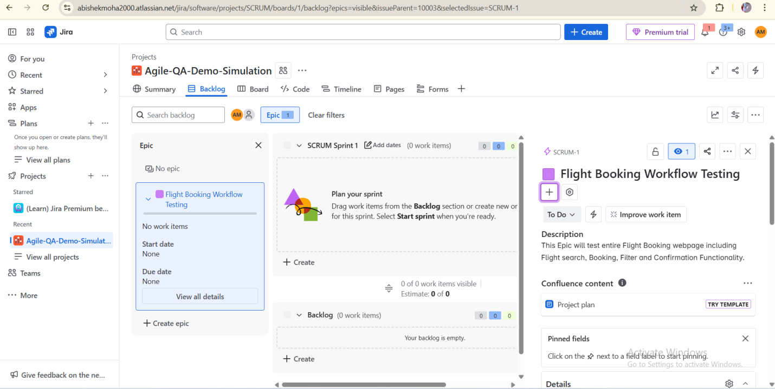

1. **Creating** **User Stories**

These are **requirements** from an end-user perspective.

1. **Story #1: Search Flights Functionality**  
   As a user, I want to search flights based on source, destination, and date so that I can view available options.

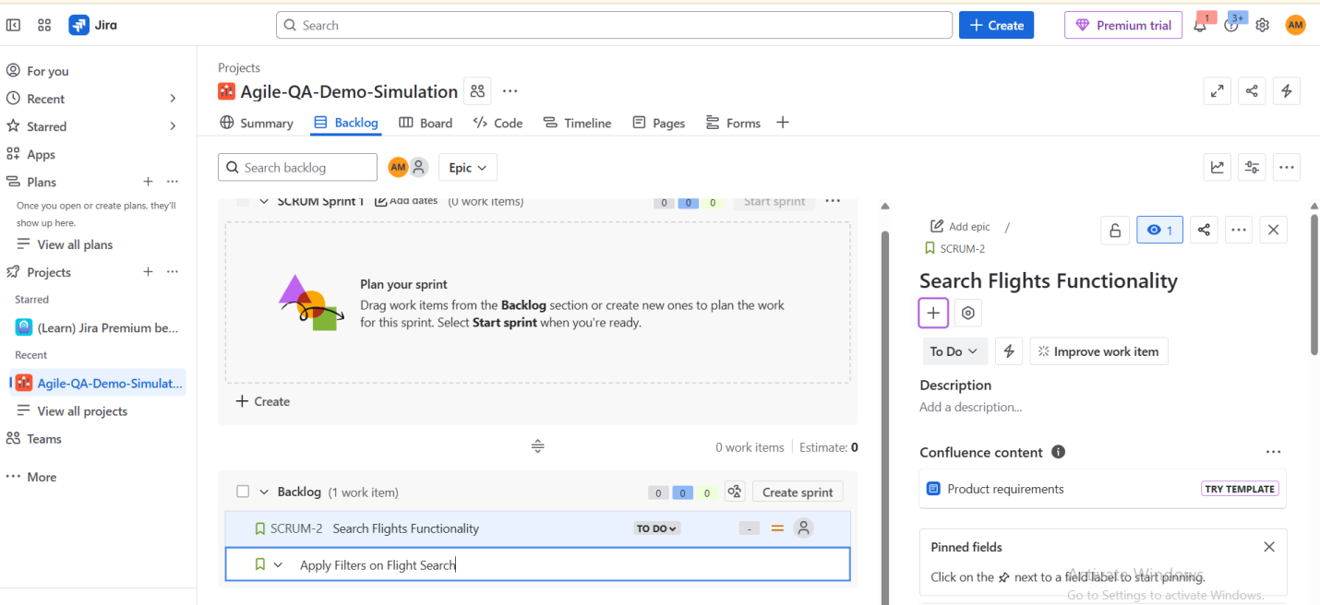

1. **Story #2: Apply Filters on Flight Search**  
   As a user, I want to apply filters (e.g., price, time, airline) so I can view relevant flights.

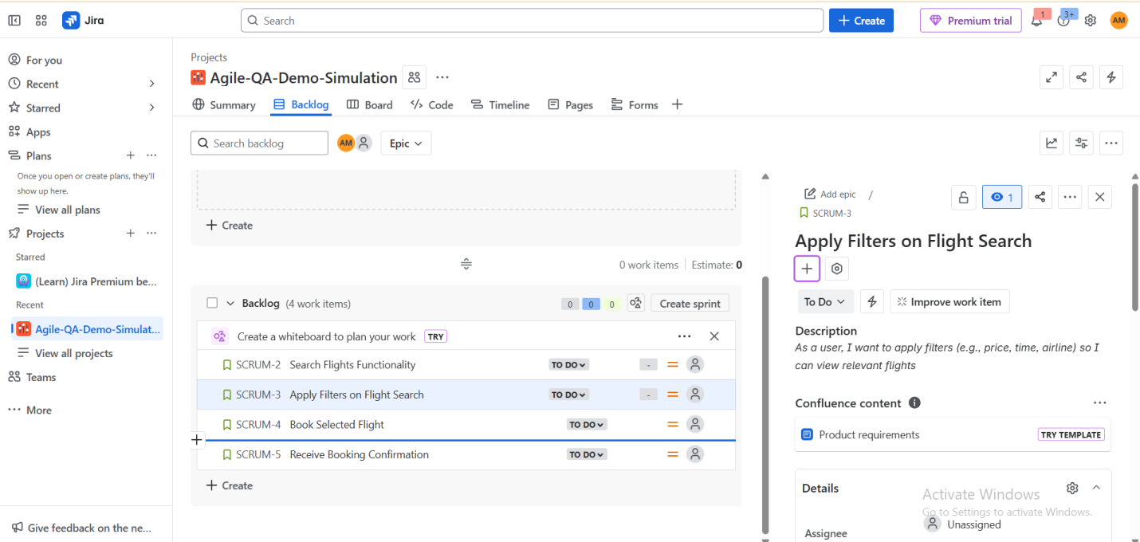

1. **Story #3: Book Selected Flight**  
   As a user, I want to book a selected flight with passenger and payment details.

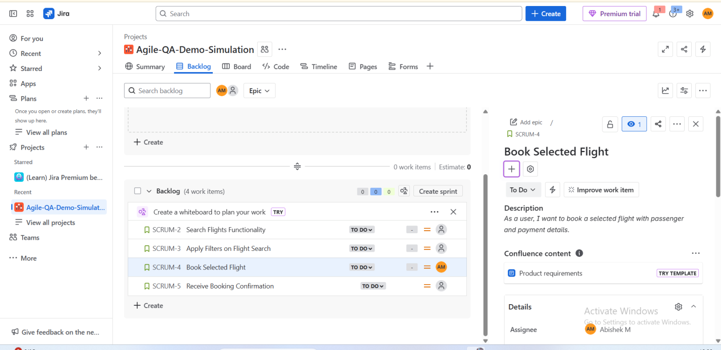

1. **Story #4: Receive Booking Confirmation**  
   As a user, I want a confirmation after successful booking with details.

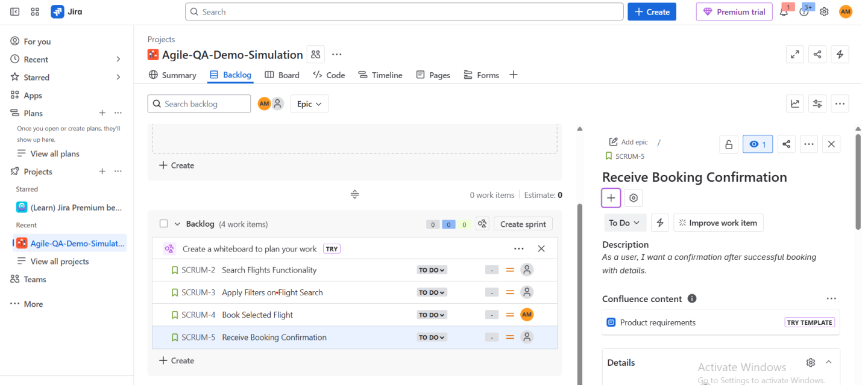

After Creating EPIC and Story separately, We can click the Story and click add EPIC and we can add already creating EPIC. It denotes that we needs to complete those story in that particular EPIC.

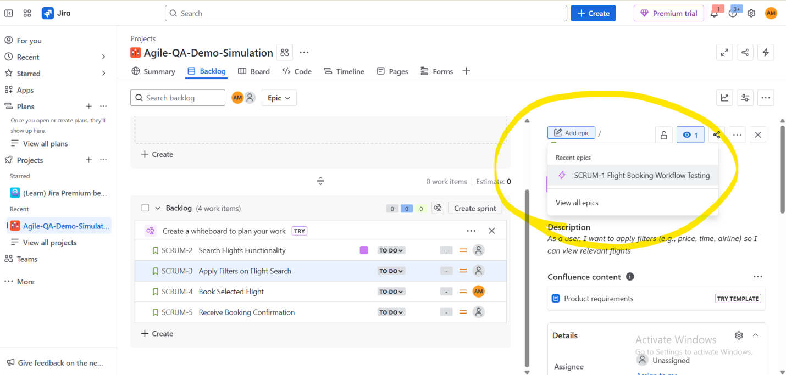

Then we have created Tasks which is nothing but work that we are going to complete in a User story. We can also assign the tasks to the individual owner.

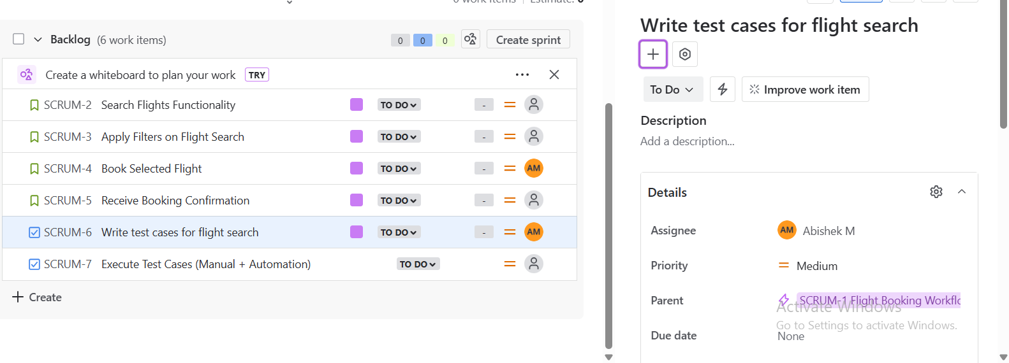

As I have already mentioned I have created 2 tasks based on a story (Search Flights Functionality) and I need to link these tasks to the story. So that In the future anyone who is looking into that Tasks can get to know that we completed that Tasks with that story. We can also assign sprint to that stories.

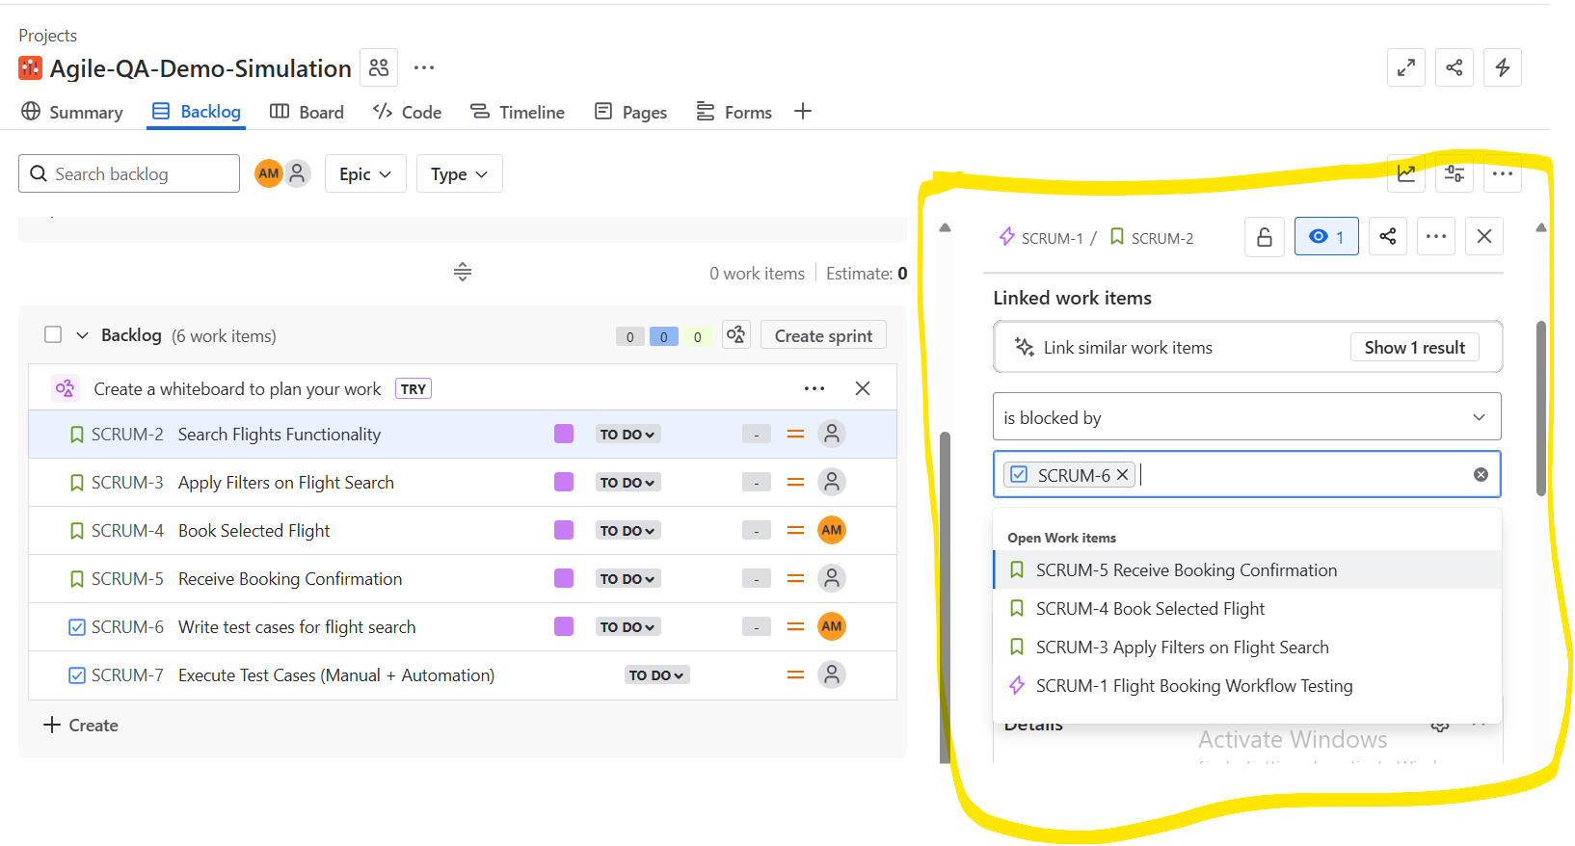

After Creating tasks and assigning to the respective story, It is essential to pick up the items which we are going to prioritise and Complete first. As shown in the below figure, The Story “Search Flight Functionality” is going to be complete first. So we are assigning to our SCRUM Sprint 1.

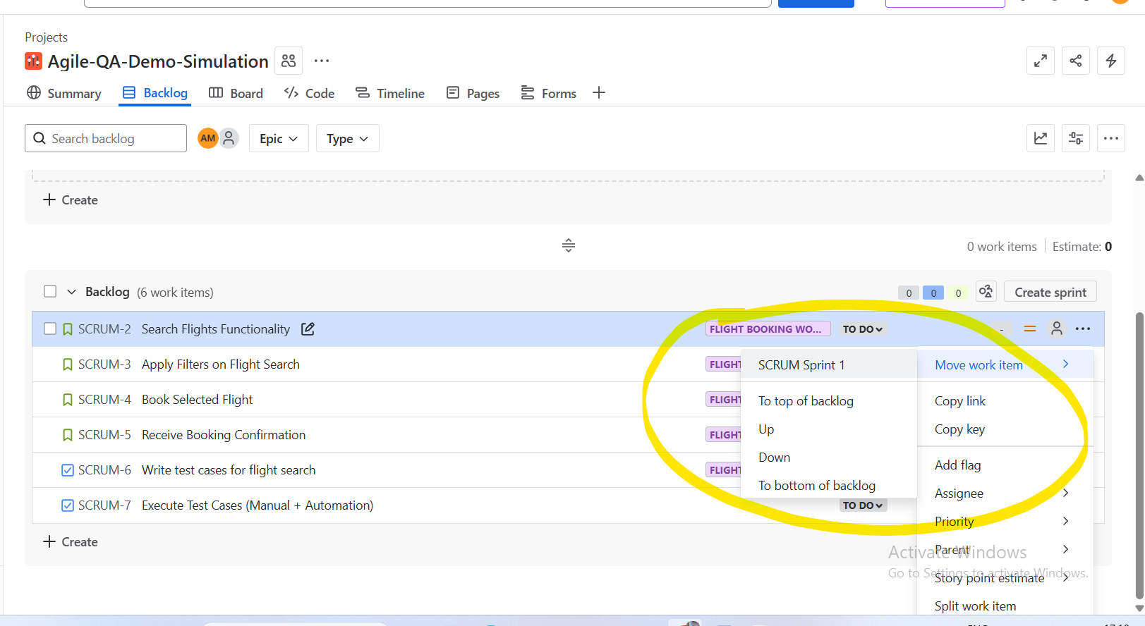

Once done with this, we can add whatever tasks we need to complete within that sprint and we can click three dots on the right corner and Edit the details of that particular sprint. Like no. of days in that sprint and Duration and The Description for that sprint too.

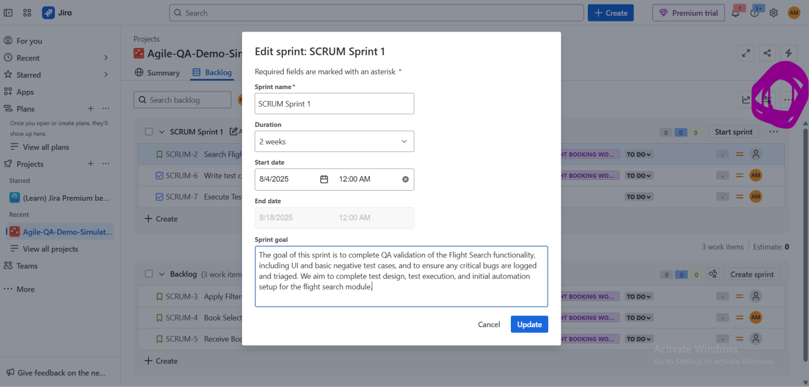

By changing the progress of the particular task as “In progress” or “In Review” or “Done” we can see the beautiful outline in Review Tab.

